2021 ACT State Self-Advocacy Conference Sponsorship Form
Please indicate which, if any, of the optional sponsorship benefits you would like below and complete the form at the bottom indicating your sponsorship amount, payment type and contact information.
Thank you for your kind support!
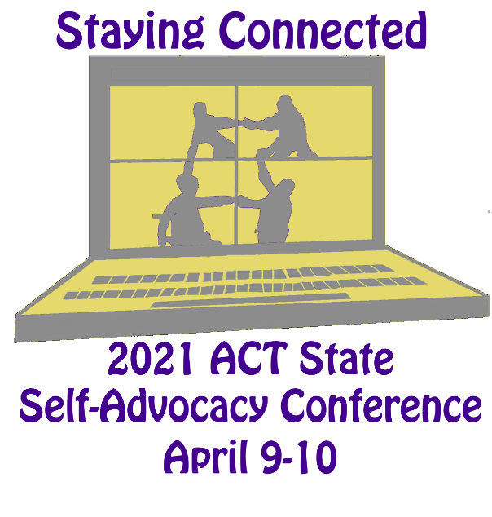
Sponsor at any level:
- listed in all print materials (sponsor by 3/31), on the website, recognized at the virtual conference.

- FREE exhibit space and TWO complimentary registrations. At this year’s virtual conference, exhibitors will have an opportunity to address a breakout room before or after the session.

YES: we would like an exhibit time for (circle one):
Friday / Saturday / Both Days

YES: we would like complimentary registrations for: _____________________________________
You can email this form to pmitchell@selfadvocacy.org, pay through our website https://conference.selfadvocacy.org or call 651-641-0297 if paying by credit card.

If paying by check, please make checks payable to “ACT” and mail with form to:

Advocating Change Together
1821 University Ave W, #345-South
St. Paul, MN 55104

Sponsorship Amount: _____________

Check (payable to ACT) Credit Card (MasterCard, Visa, Discover or American Express)

Credit Card Number: _____________________________________ Credit Card Zip Code_____________

Expiration Date: _____________ Code on Back: ______

Agency/Organization/Individual (as you would like it to appear in conference materials):

_________________________________________________________________________________
Contact Person: ___________________________________________________________________
Address: ___________________________________________________________________
City: _________________________________ State: ________ Zip: ___________

Phone: ___________________________ Email: _________________________________

